Start to Checkpoint 1
College to Cathedral (3 miles)
1. From the start line follow the signs to leave the College Campus and turn right at the A390 dual carriageway keeping to the nearside footpath for about half a mile. Pass the retail park and hospital on the left and continue straight on at the first roundabout. At the next traffic light, cross the A390 and continue on the other side of the road until turning left onto Treliske Lane, marked with brown ‘Golf Club’ road sign.
2. Follow Treliske Lane, taking 3rd right turn just before end of speed restrictions (not earlier Trevean Road) at pedestrian walking directions to City Centre and Station onto Coosebean Greenway. Follow Greenway for ½ mile (always taking left hand path whenever it divides) and at end go through the gate turn right into lane, following pedestrian sign to City Centre. After about 60 yds take drive/path on left to Millstone and Coosebean House. Shortly after, just round first bend, go right through gate onto public footpath through woods and follow to end. Through the metal kissing gate, cross the road and turn left (Bosvean Gardens), then, shortly after the bridge at junction, continue right onto St Georges Road. Keep on St Georges Road all the way to the railway viaduct. Just after viaduct, on the left had side, go through the granite pillars in the wall and follow the path through the small grassy area and through the metal gate.
3. Cross the river by the footbridge, turn right and continue to follow “The Leats” pathway behind converted chapel alongside the river with Victoria Gardens to your left. Cross Edward Street at Richmond Ho and cross Castle Street at Elizabeth Ho., continuing straight. Take the passageway to the left between the back of WH Smith and post-box and turn right when you are facing the library*. A few yards on, you will see Samaritans Information Stand in front of the Cathedral*. Bear left down to the right of the Cathedral, turning right into the passageway with Philip Martin estate agents on the corner.
Truro Centre to Calenick (1 mile)
4. Emerge onto Boscawen Street, cross and continue opposite with Lloyds Bank on your right. Shortly after, turn first left onto Lemon Quay. Exit Lemon Quay at the bottom via the underpass next to M&S. Sharp left at the end of the underpass and then right onto the path along the riverside behind Tesco. Leaving the supermarket behind and keeping the river on your left stay on the pathway to the end where it turns up to meet a road. Left here and follow pavement till you cross up onto Gas Hill. Climb a few metres to a path (disused railway) leading off on the left, which you follow up to a gate where the track crosses a lane. Turn left onto the lane to descend to the Checkpoint 1 at Calenick House*. Check In!
Checkpoint 1 to Checkpoint 2
Checkpoint 1 to Coombe (4 miles)
5. From Calenick House* continue downhill and turn left at the junction. After a steep climb and about a quarter of a mile, at the T-junction in Porthkea, go left signed Coombe Cowlands. Continue as the lane climbs after Porthkea, ignoring turnings to Cowlands on the right and later Old Kea on the left. Shortly after this and just past Lower Lanner Farm (tearoom) take the public footpath on the right to Coombe. Go through the farm gate and over the ridge as the path bears slightly left, leaving the clump of trees and bench to your right to reach a wooden pedestrian gate in the hedge opposite. Descend alongside tea plantation, cross stile at bottom of field and keep straight on down to creek, as the path becomes a drive.
Coombe to Come-to-Good (1 ½ mile)
6. In Coombe*, at the water’s edge turn right to follow telegraph-poled track keeping water on your left. (If the tide is high, retrace up the footpath signed to Cowlands, but turning left after the orchard to rejoin creekside path further up). After Bethel Cottage, at post with life ring, turn up then bear second left in front of Turn-a-Penny Cottage (named after bric-a-brac stall once here), following yellow arrow. After 2 stiles, at the creekside cottage, take second (nearer to the creekside) public footpath/track on right signed to Cowlands, (NOT first footpath up through woods) turning left on tarmacked lane at end and down into Cowlands. In Cowlands* at the head of the creek, take public footpath to the left of the thatched house (the 26-mile route continues on the lane here) which goes behind the house and through the woods, then up the hill to an opening at the top of the field. Go left on the track and then after about one hundred yards, having passed a driveway on the right, turn right on to the public footpath. Follow this between the hedge and new fencing, round to the left, past the 2 metal farm gates and between two hedges. Just up from here the path continues left through a metal kissing gate into a field. Follow the right-hand hedge to reach another gate. Go through and again follow the right-hand hedge to go through gate at the top. Here the path cuts the corner across the field towards the buildings (Penelewey Barton). Continue past the converted barns and past Penelewey Barton House*, until the bungalow at the bend, where you follow footpath through a metal kissing gate with footpath sign. Follow footpath across the field diagonally to a stile in the corner, to the left of the lowest cream-coloured house. The narrow path continues past cottages to the road. Take great care here. Cross and walk left on the verge past the Punchbowl & Ladle and just after the pub, take the public bridleway leading off on the opposite side.
7. Follow the footpath down to Come-To-Good where you will see Checkpoint 2 at the thatched Friends’ Meeting House*.
Check in at Checkpoint 2!
Checkpoint 2 to Checkpoint 1
Come-to-Good to Calenick (2 miles)
8. Leave Checkpoint 2 and continue up the footpath to the right of the Friends’ Meeting House* and bear left round the end of the vines. Follow this path through the woods, across the stream over the stile and climb to continue through a gate. Follow path between two fences and another gate. About two thirds of the way through this field the path bears slight left to a granite stile by the roadside, not through the gate (probably locked).
9. Over the stile, cross the road turn right and follow with care for a very short stretch to the fork. Here turn sharp left onto Halvarras Road and continue past the Almshouses* on your left and at the bend, turn right onto Penhalls Way. Continue to the end and cross to public footpath opposite. Pass the plaque with the explanation of the village name, Playing Place*, and turn right where the path ends at the road, onto pavement which soon becomes a footpath, raised above the road. Where footpath ends carry straight on down the hill leaving Kea School on the right and re-entering Calenick, check in again at Checkpoint 1 in Calenick House*.
Checkpoint 1 to Finish
Calenick to College (3 ½ miles)
10. Leave Calenick House and walk back up the hill to where the lane crosses the disused railway line, with signage and wooden fences.
11. Go through the wooden gate in the fence to the left and follow the old railway line for about ¾ mile. There is a deviation just before the second bridge, leave the old railway and climb through fence and continue up the field. Go through the gate at the top, turn left onto the lane and pass back under bridge. Follow this road for about half a mile and after the junction on the right, just before a bridge over a stream, take the footpath to the right. Keep to the footpath, and fork right to go through a metal gate. Carry on through the bushes and into open ground. Climb and keep to the right to where the path leads through a gap in the hedgerow to a footbridge over the railway. Follow the path to the top of the hill and round to the left. Shortly after take a side turn to the right, which leads into the back of a children’s park/exercise area. Walk through the park, exit and turn left, soon taking the side track descending to the left, which leads onto Newbridge Lane. Here turn up right, to take Sparnock Grove, and later Trudgeon Way to the right, which becomes a tarmacked pedestrian lane. Emerge through gate at the end and continue straight on Ventongoose Road until it bends 90 degrees to the right, and you go through a gap in the hedge straight ahead. Turn left onto path, up to the wooden walkway on the left which leads you through a Nature reserve. At the end of walkway turn right onto a path which twists and turns until you get to the edge of the College campus, with Richard Lander School on your left. At the playing fields, take the right-hand path towards the large college (Fal) building ahead. Finish!
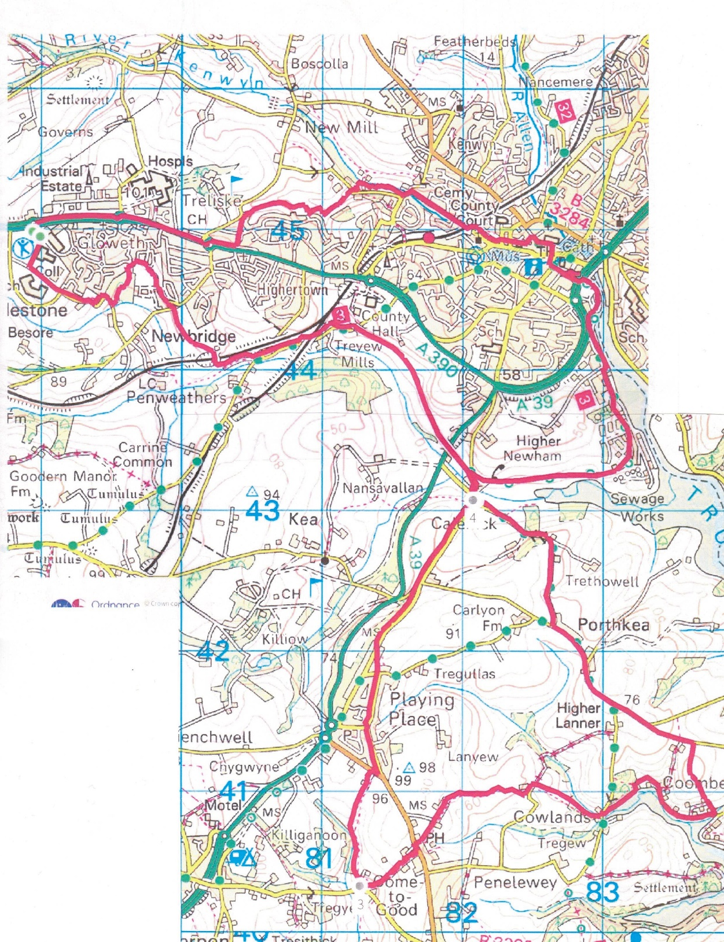
*Points of historical interest (See separate sheet)
Hints:
Navigating through the city
If you lose the marked way going into the city, head for landmarks – Cathedral (clearly visible everywhere), Boscawen Street (central cobbles street) then head to Lemon Quay (ask for Marks and Spencer). From there the underpass takes you to Tesco car park.
You can always use Google Maps in walking mode for directions if you are lost! Put in Tesco or Marks and Spencer as a destination.
Last part of return leg
If you lose the marked way head north to the A390 and follow the footpath back to the College. Or use Google Maps to give you a walking route back to the Finish return – Truro College postcode is TR1 3XX

