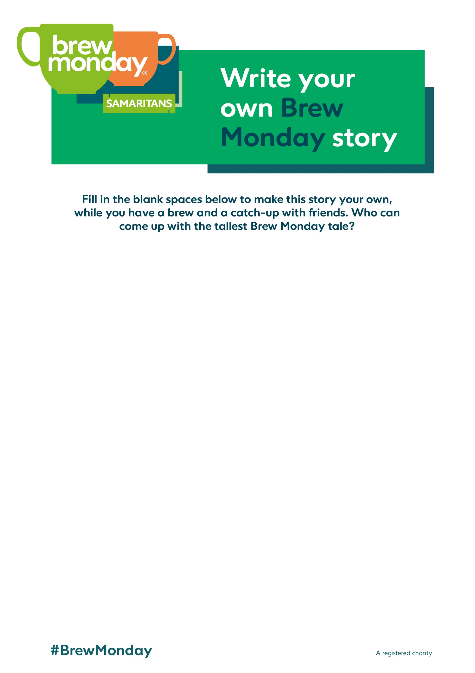
One of the things about Brew Monday is that I get to have a and a catch-up with . Brew Monday isn’t just for January either, if I want to have a cuppa on a in , I can!
Next time, I’m going to invite , make and do in . Almost anything goes, as long as we’re connecting over a !
Does this all sound a bit ? It’s not as ridiculous as the ‘Blue Monday’ myth, which isn’t based on any or science. Samaritans Brew Monday takes Blue Monday and turns it into , encouraging us all to reach out for a cuppa and a chat. So I say, out with the blue and in with the !

