I | Q | D | P | O | A | T | T | A | R | Y | N | L | W | G | J | L | L | E | G | Z | L | L | U | X
G | R | Y | C | A | B | E | T | D | H | Q | W | J | L | B | Z | C | A | U | T | E | G | I | H | I
L | T | N | E | I | D | N | H | R | A | G | J | C | V | Z | V | A | N | G | Z | K | D | S | M | A
D | R | V | C | H | J | L | J | I | J | N | Q | E | Y | V | Z | L | U | C | I | P | A | T | I | N
I | E | U | T | N | U | X | R | Y | J | Z | W | Y | D | G | C | Y | B | V | O | R | Y | E | L | S
U | A | C | X | K | I | B | J | H | D | K | L | P | C | X | I | U | G | R | U | T | R | N | K | N
W | T | O | J | Q | C | X | P | C | A | S | J | O | G | D | G | Z | P | Z | V | R | F | I | T | O
H | S | N | P | H | E | W | O | T | Y | D | Z | I | K | G | Z | C | U | P | E | H | J | N | S | U
M | Q | V | T | X | F | A | E | Y | J | B | W | H | X | I | R | R | L | G | A | U | Z | G | W | A
P | D | E | E | T | H | T | G | F | T | G | L | Y | N | W | B | R | E | W | M | O | N | D | A | Y
T | H | R | A | F | Z | D | D | M | S | V | E | J | T | J | I | W | C | F | P | M | O | Y | X | C
L | N | S | B | P | W | X | G | M | A | A | U | L | D | M | M | N | E | R | M | J | L | I | Y | O
D | I | A | A | W | H | X | R | E | M | D | O | G | T | R | L | D | X | Q | W | Q | E | M | Z | F
B | W | T | G | P | M | E | Q | N | A | G | X | J | A | Z | N | Z | B | P | G | J | M | P | O | F
U | O | I | H | R | K | K | X | T | R | M | I | O | L | V | M | A | I | E | E | P | W | I | S | E
C | U | O | H | W | J | L | S | A | I | S | D | P | K | F | C | O | N | N | E | C | T | E | D | E
U | O | N | V | L | W | H | P | L | T | C | A | Y | J | T | U | T | W | Q | T | C | K | X | K | Y
V | Q | U | U | L | K | T | I | H | A | R | F | S | B | D | H | C | I | C | V | B | M | V | Y | A
P | W | Z | D | L | T | W | S | E | N | X | Y | K | D | F | Q | K | J | U | D | K | O | Y | E | C
C | Z | N | L | J | Z | H | U | A | S | N | K | E | H | F | V | P | A | S | D | R | X | V | K | L
A | H | M | R | N | N | F | P | L | B | S | Z | T | P | C | L | X | U | V | Y | V | V | Y | X | E
O | J | A | O | Z | M | R | P | T | M | N | T | M | L | B | P | K | R | Q | X | S | T | E | E | P
X | E | P | T | T | O | J | O | H | Y | T | R | T | I | M | X | B | V | E | G | N | X | G | G | X
R | X | O | M | P | L | Z | R | J | T | X | L | Y | D | T | H | K | S | Y | A | G | Y | I | X | P
P | A | P | T | B | Y | D | T | X | Y | C | D | D | K | Z | I | R | B | I | S | C | U | I | T | S
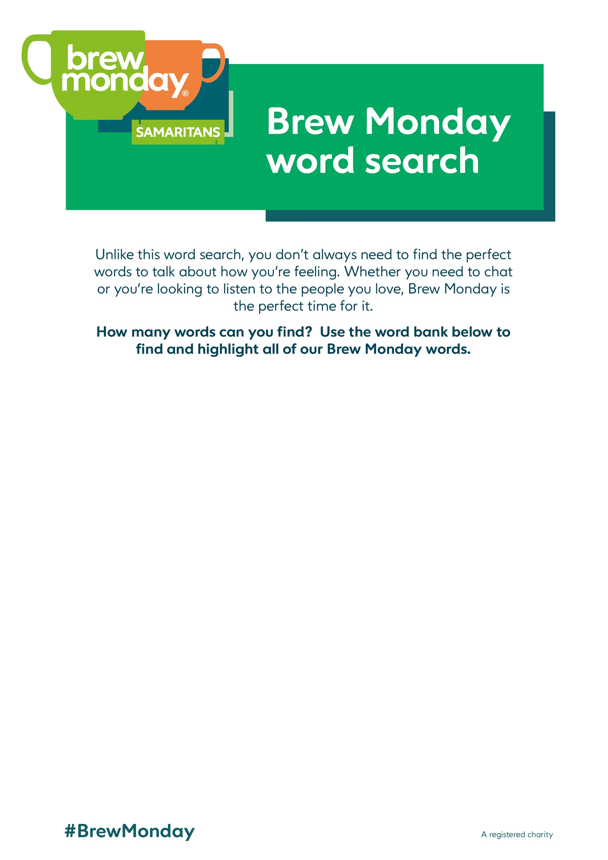
Conversation | Mental Health | Brew Monday | Samaritans
Connected | Listening | Biscuits | Support
Coffee | Treats | Tea bag | Juice
Steep | Cuppa | Chat | Talk

