WSPD Suggested Social Posts
What helps you to stay hopeful when you’re struggling?

Copy: I believe we can all play an active part in suicide prevention, which is why I’m supporting @samaritans this World Suicide Prevention Day.

They've compiled a list of tips and resources to help you remain hopeful during a difficult time. https://bit.ly/2XIR8q0 #WSPD

Asset: ‘What do you do to stay hopeful when you’re going through a difficult time?’
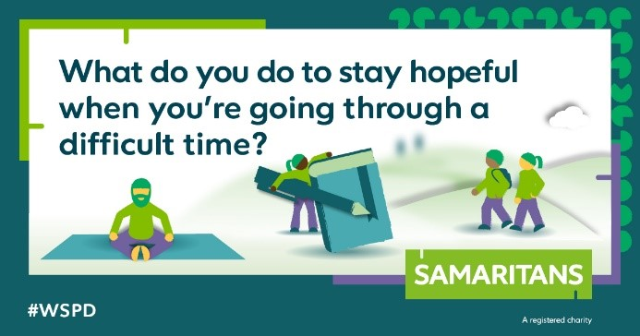
Link: https://www.samaritans.org/how-we-can-help/if-youre-having-difficult-time/staying-hopeful

Tip 1: Going on a walk with a Friend

Copy: Going on a walk with friends or family can be a great way to help boost our overall mood and wellbeing.

@samaritans have some great resources to help you look after yourself and bring hope in these tough times. #WSPD https://bit.ly/2XIR8q0

Asset: ‘Simply going on a walk with a friend could help bring hope during a difficult time.’
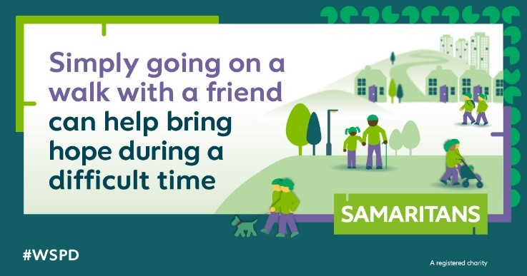
Link: https://www.samaritans.org/how-we-can-help/if-youre-having-difficult-time/staying-hopeful

Tip 2: Keeping a Gratitude Journal
Copy: Connecting with how you're feeling by writing your thoughts down could help you stay safe in a crisis.

@samaritans have shared practical techniques to help bring hope, which I’m sharing today in support of #WorldSuicidePreventionDay #WSPD https://bit.ly/2XIR8q0

Asset: ‘Keeping a gratitude journal can give you the opportunity to focus on the things you’re grateful for and can help improve your optimism.
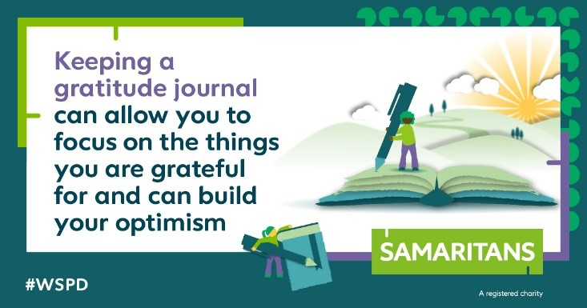
Link: https://www.samaritans.org/how-we-can-help/if-youre-having-difficult-time/staying-hopeful

Tip 3: Pause and Reflect
Copy: Over the past year, many of us may have experienced feelings of overwhelm and uncertainty.

@samaritans have shared useful tips on how you can take the time to pause and reflect to help you manage your thoughts. https://bit.ly/2XIR8q0 #WSPD

Asset: ‘Taking the time to pause and reflect may help you prioritise and manage your thoughts.’
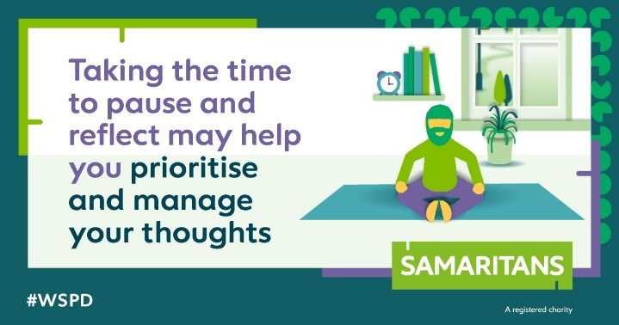
Link: https://www.samaritans.org/how-we-can-help/if-youre-having-difficult-time/staying-hopeful

Signposting

Copy: You may have seen a lot of difficult content this #WSPD. Remember, @samaritans are open 24/7 for emotional support if you need to talk.

You can call them any time, day or night, on 116 123, or email jo@samaritans.org 💚

Asset:
